**Project Name: Mitti prodcuts (ilovemitti.com)**

**Project Member:**

**Jaydeep kumbhar 210543181047**

**Vaibhav Jadhav 210543181031**

**Parmeshwar Nandgave 210543181060**

**Pawan Dukare 210543181067**

**Abstract:**

India is well known for its tradition and so is its tradition of cooking with earthenware. It’s an age-old concept that has deserted with time. This golden concept was then washed over by modernization as we moved to the stainless steel or bone china or melamine era.

One can get a rare antique of an earthen pot in few homes these days, the reason being its natural benefits. Earthenware has tremendous health benefits. Cooking food with it embarks nutritional value of the clay to the food. The porous material of clay helps water seep through it, letting you enjoy the mildly cool water. Not only this, but the mineral composition and porous nature of clay pots and other clay products also accentuate the flavour of the food we eat.

ilovemitti is all about re-growing these rich lost roots of Indian culture into the modern environment. iloveMtiiti prides its initiative towards preserving our old culture. We produce clay products and clay pots that lead to a healthy, natural life and also revive our rich tradition

In order to develop an ilovemitti website, a number of Technologies must be studied and understood. These include multi-tiered architecture, server and client-side scripting techniques, implementation technologies such as Spring BOOT, programming language (such as Core Java, Advance Java), relational databases (such as MySQL).

**Implementation Technologies:**

1. **Spring Boot:**

Spring Boot is a project that is built on the top of the Spring Framework. It provides an easier and faster way to set up, configure, and run both simple and web-based applications. It is a Spring module that provides the **RAD (*Rapid Application Development*)** feature to the Spring Framework. It is used to create a stand-alone Spring-based application that you can just run because it needs minimal Spring configuration.

In short, Spring Boot is the combination of **Spring Framework** and **Embedded Servers**.

In Spring Boot, there is no requirement for XML configuration (deployment descriptor). It uses convention over configuration software design paradigm that means it decreases the effort of the developer. We can use Spring **STS IDE** or **Spring Initializr** to develop Spring Boot Java applications.

.**1.1 Features of Spring Boot**

**1. Web Development**

It is a well-suited Spring module for web application development. We can easily create a self-contained HTTP application that uses embedded servers like **Tomcat, Jetty,** or Undertow. We can use the **spring-boot-starter-web** module to start and run the application quickly.

2. **Spring Application**

The Spring Application is a class that provides a convenient way to bootstrap a Spring application. It can be started from the main method. We can call the application just by calling a static run() method.

3. **Application Events and Listeners**

Spring Boot uses events to handle the variety of tasks. It allows us to create factories file that is used to add listeners. We can refer it to using the **Application Listener key**.

Always create factories file in META-INF folder like **META-INF/spring .factories**.

4. **Admin Support**

Spring Boot provides the facility to enable admin-related features for the application. It is used to access and manage applications remotely.

5. **Externalized Configuration**

Spring Boot allows us to externalize our configuration so that we can work with the same application in different environments. The application uses YAML files to externalize configuration.

6. **Properties Files**

Spring Boot provides a rich set of **Application Properties**. So, we can use that in the properties file of our project. The properties file is used to set properties like **server-port =8082** and many others.

**7.Logging**

Spring Boot uses Common logging for all internal logging. Logging dependencies are managed by default. We should not change logging dependencies if no customization is needed.

**8.Security**

Spring Boot applications are spring bases web applications. So, it is secure by default with basic authentication on all HTTP endpoints. A rich set of Endpoints is available to develop a secure Spring Boot application.

## **1.2 Advantages of Spring Boot**

* It creates **stand-alone** Spring applications that can be started using Java **-jar**.
* It tests web applications easily with the help of different **Embedded** HTTP servers such as **Tomcat, Jetty,** etc. We don't need to deploy WAR files.
* It provides opinionated '**starter**' POMs to simplify our Maven configuration.
* There is no requirement for **XML** configuration.
* It offers a **CLI** tool for developing and testing the Spring Boot application.
* It offers the number of **plug-ins**.
* It also minimizes writing multiple **boilerplate codes** (the code that has to be included in many places with little or no alteration), XML configuration, and annotations.
* It **increases productivity** and reduces development time.

1. **The JDBC Template**

The central class of the Spring JDBC abstraction framework is the **Jdbc Template** class that includes the most common logic in using the JDBC API to access data, such as handling the creation of connection, statement creation, statement execution, and release of resource. The**Jdbc-Template**class can be found in the **org.springframework.jdbc.core**package.

The **JdbcTemplate** class instances are thread-safe once configured. A single **JdbcTemplate** can be configured and injected into multiple DAOs.

We can use the **JdbcTemplate** to execute the different types of SQL statements. **Data Manipulation Language** (**DML**) is used for inserting, retrieving, updating, and deleting the data in the database such as **SELECT**, **INSERT**, or **UPDATE** statements

**2.1** **MySQL**

MySQL, the most popular Open Source SQL database management system, is developed, distributed, and supported by Oracle Corporation.

**Features of MySQL:**

* **MySQL is a database management system.**

A database is a structured collection of data. It may be anything from a simple shopping list to a picture gallery or the vast amounts of information in a corporate network. To add, access, and process data stored in a computer database, you need a database management system such as MySQL Server. Since computers are very good at handling large amounts of data, database management systems play a central role in computing, as standalone utilities, or as parts of other applications.

* **MySQL databases are relational.**

A relational database stores data in separate tables rather than putting all the data in one big storeroom. The database structures are organized into physical files optimized for speed. The logical model, with objects such as databases, tables, views, rows, and columns, offers a flexible programming environment.

* **MySQL software is Open Source.**

Open Source means that it is possible for anyone to use and modify the software. Anybody can download the MySQL software from the Internet and use it without paying anything.

* **The MySQL Database Server is very fast, reliable, scalable, and easy to use.**

MySQL Server was originally developed to handle large databases much faster than existing solutions and has been successfully used in highly demanding production environments for several years. Although under constant development, MySQL Server today offers a rich and useful set of functions. Its connectivity, speed, and security make MySQL Server highly suited for accessing databases on the Internet.

* **MySQL Server works in client/server or embedded systems.**

The MySQL Database Software is a client/server system that consists of a multithreaded SQL server that supports different back ends, several different client programs and libraries, administrative tools, and a wide range of application programming interfaces (APIs).

1. **Hardware and Software Requirements (Minimum):**

**Hardware:**

1. Intel i3 processor 3rd generation or later / AMD Ryzen 200 2nd generation or later

2. 4 GB DDR3 ram.

3. Windows 7 Home edition or later.

4. 200 GB HDD Space

5. Data Connection 200 kbps

**Software:**

1. Eclipse 4.7 Oxygen
2. MySQL 5.7 with Workbench 8.0
3. Google Chrome version 79.0
4. Apache Tomcat Server 8.5
5. Maven Dependencies
6. **ER Diagram:**

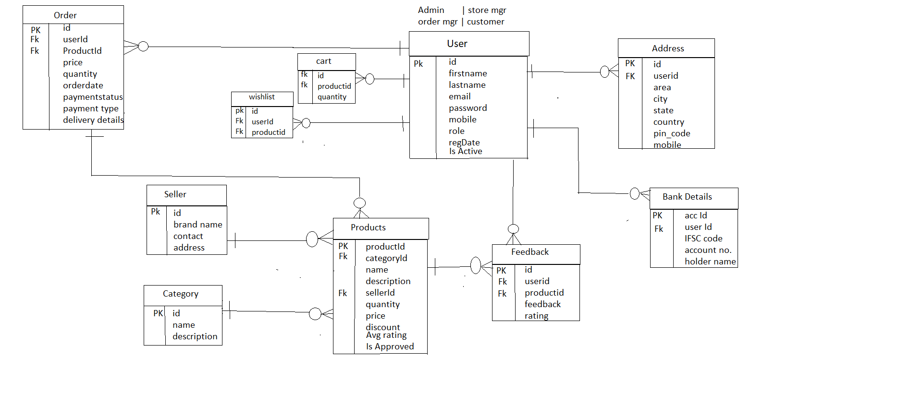

Figure 1: ER Diagram

|  |  |  |  |  |  |
| --- | --- | --- | --- | --- | --- |
|  | |  | |  | |
|  |  | |  | |  | |  |  |  |  |

1. **Table Structures:**
2. **Table name: User {Admin | Customer| Store Manager | Order Manager }**

**Column name Type**

UserId int (11) NO PRI auto_increment

Name varchar(20) YES

Password varchar(20) YES

EmailId varchar(40) YES

ContactNo varchar(20) YES

role varchar(20) YES

regDate varchar(20) YES

picture varchar(20) YES

1. **Table name: Address**

**Column name Type**

Address_Id int (11) NO PRI auto_increment

User_Id varchar(50) YES

Area varchar(10) YES

city varchar(30) YES

state varchar(50) YES

country varchar(50) YES

pin_code varchar(50) YES

mobile varchar(50) YES

1. **Table name: Products**

**Column name Type**

productId Id int (11) NO PRI auto_increment

CategoryId int (11) YES MUL

Name varchar(40) YES

Description varchar(40) YES

sellerId varchar(10) YES

quantity varchar(10) YES

Price varchar(20) YES

1. **Table name: Category**

**Column name Type**

CategoryId int (11) NO PRI auto_increment

name varchar(11) YES MUL

description varchar(100) YES

**5. Table name: seller**

**Column name Type**

sellerId int (11) NO PRI auto_increment

brand_name varchar(200) YES

contact varchar(200) YES

address varchar(200) YES

**6. Table name: cart**

**Column name Type**

userId int (11) NO PRI auto_increment

productid varchar(200) YES

quantity varchar(200) YES

**7. Table name: Order_details**

**Column name Type**

orderDetailsId int (11) NO PRI auto_increment

orderId varchar(200) YES

totalAmount varchar(200) YES

**6. End to End Flow of Application:**

**User:**

* 1. User will login to the portal or will have to register if he is not a registered user.
  2. After registration User will login and Dashboard page will be displayed to him which will display the previous complains and its status if any.
  3. From that page can User can click on the ‘**file new complain’** button and reach the complaint details form page.
  4. In the complaint details page the User has to pick a category among the **Eight**predefinedcategories and brief about the problem with affected area (address) and image of the object or place.
  5. A ‘**summary report’** will be displayed on the Website showing all the details of the complaint.
  6. User will only be able to see his complaint after the complaint has been ‘**Received’**or either ‘**Resolved’** by the respective admin of the category chosen.

**Admin:**

1. Admin will login as Admin from the ‘**Admin login**’ page and will be able to see his share of Complains filed by the Users of a particular area.
2. Admin can Review the complaint and after understanding it Admin will ‘**Receive’** the complaint.
3. It is the job of Admin to assign appropriate contractor or service person to resolve the matter at the hand as soon as possible to avoid disturbance among the public.
4. After conforming about the completion/resolving of the problem, Admin will check the status of the problem as ‘**Resolved’**and head over to the next complaint if any.
5. Future Scope of Project

* Being a customer friendly company with 100% customer satisfaction
* To be the best eco-friendly company worldwide
* Excel in our domain of eco-friendly earthenware
* Encourage our customers to buy eco-friendly and organically certified products
* Creating a work-friendly environment for our staff, suppliers, and customers thus promoting oneness and encouraging self-development.

**Thank You!**